# Claims Mirroring Overview

**Objective:** **1**

**Background:** **1**

**Project Requirements:** **3**

**Open Items to Discuss:** **3**

# Objective:

Generate a Microsoft Word Add-in, that accomplishes two tasks: dynamically generate “claim” objects via user inputs by the highlighting method and enable the user to produce the “claim” object in text at the end of the document with the parameters the user input.

# Background:

Claims are always written in the same format. A claim is made up for two parts: a preamble and steps. Each step can then contain multiple “wherein” statements, however a step might not have any “wherein” statements either. You can see below, the first step contains two “wherein” statements but the second step has none.

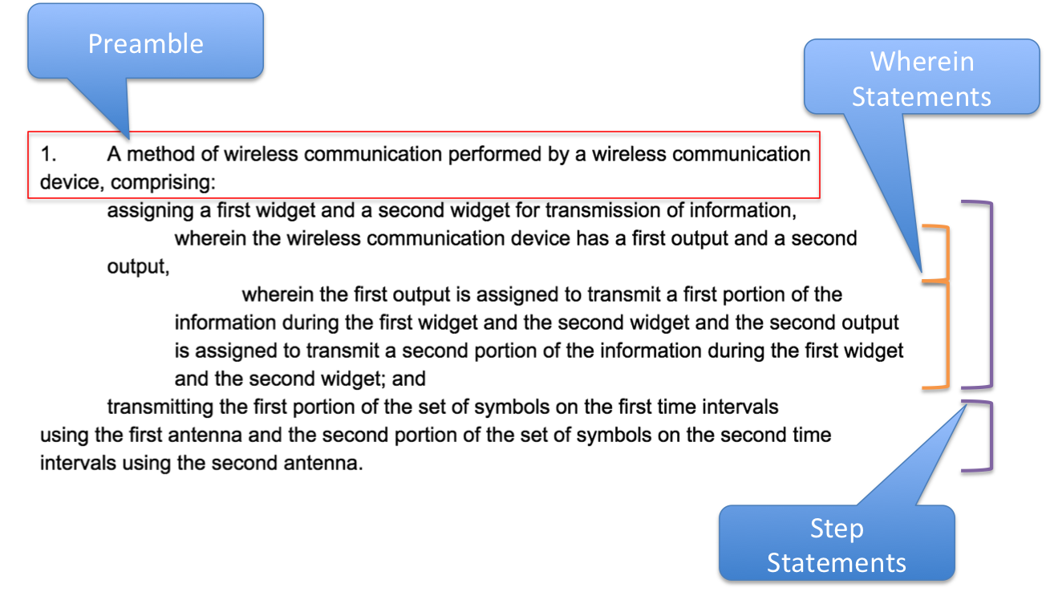

Each claim has a specific format depending on the type of claim. For clarity, the above verbs: **assigning** and **transmitting** will be referred to as “**action verbs”** in the below chart. The following table describes how to identify the different claim types:

|  |  |  |  |
| --- | --- | --- | --- |
| **Claim Type** | **Preamble** | **Steps** | **Formatting** |
| Method | “A method of wireless communication performed by a wireless communication device, comprising:” | Begin with action verb. An “ing” verb. | SAME |
| Device | “A device for wireless communication, comprising: memory; and one or more processors coupled to the memory, the memory and the one or more processors configured to:” | Begin with the action verb, except no “ing” | SAME |
| Apparatus | “An apparatus for wireless communication, comprising:” | Begin with “means for” followed by the action verb | SAME |
| CRM | “A non-transitory computer-readable medium storing one or more instructions for wireless communication, the one or more instructions comprising: one or more instructions that, when executed by one or more processors of a device, cause the one or more processors to:” | Same as device | SAME |

# Project Requirements:

* A user must be able to use the application in Microsoft Word without having to navigate to any other applications.
* A user must be able to use a written method claim as the input for the application.
  + The number of inputs will depending on the number of steps in each claim, but it will have a minimum of two with an infinite maximum
* A user must be able to create a Device, Appartus, and CRM claim based on their inputs.
* The generated claims must have the exact same formatting as the method claim used as the input.
* The created claims must be able to be to placed in the document without moving existing text.
* The application must run in a cloud based version of Microsoft 2013 and greater

# Open Items to Discuss:

* Is it possible to conjugate the action verb without having a user enter the other form?
* Sometimes the action verb comes secondly after the word “selectively”, we will need to avoid selecting this word as the action verb. Happy to discuss best method.